NOTE: This bulletin was folded and bound.
Therefore, the pages will appear to be out of order here.

Our Love Story
Jennifer
and
Christopher
November 24, 2001

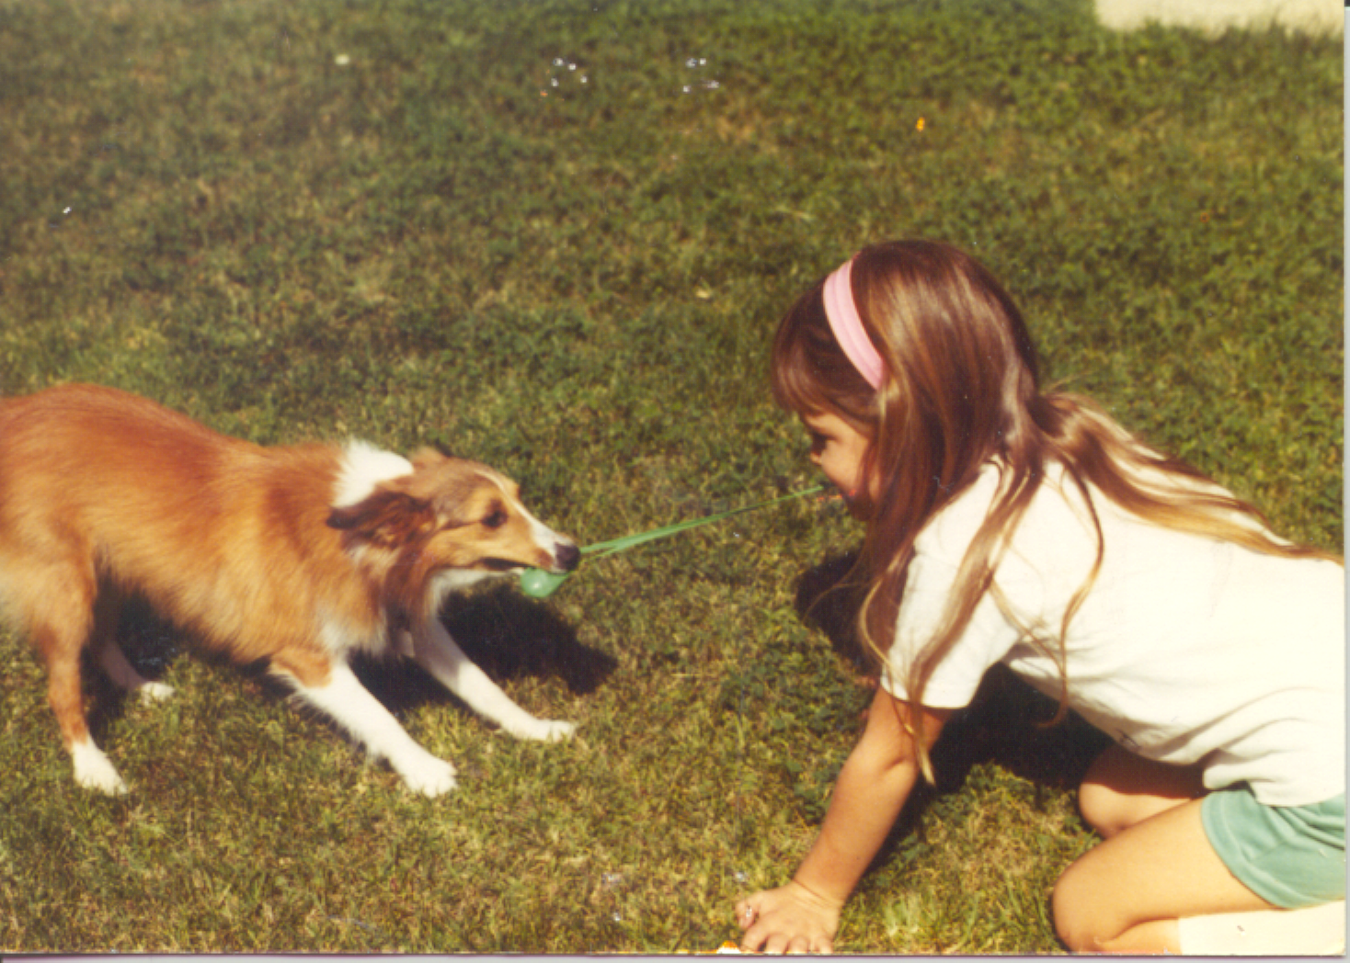
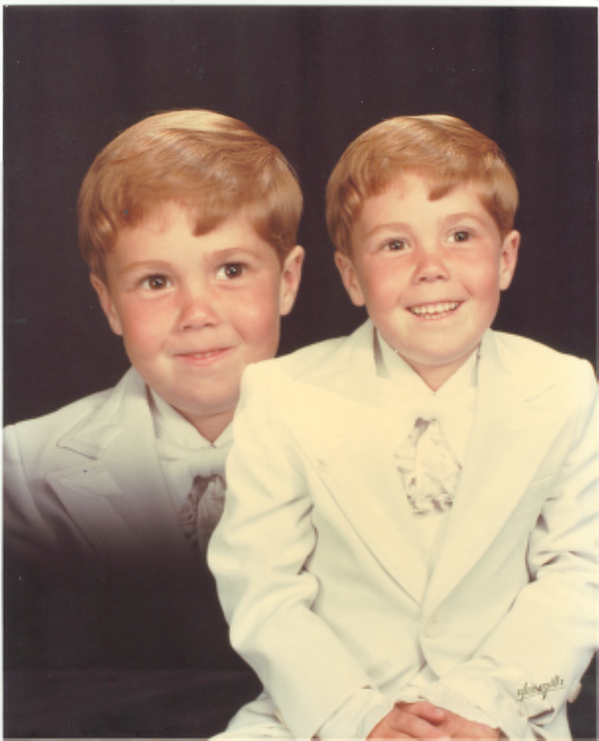
Once Upon A Time…there was a little boy named Christopher and a little girl named Jennifer. If you believe in soul mates, fairly tales, and true love, you will understand our story. We met twelve years ago. As soon as we were introduced to one another we seemed to click. It is not very often that you meet someone you can spend hours with and not need to say a word, or that you can sit and talk to on the phone every day until you fall asleep. It usually takes a lifetime to establish that type of trust. The kind of understanding where one look says a thousand words. For us it was almost immediate. Though we dated other people and lived 30 minutes away from one another, we were practically inseparable. At times we used to wake up on the phone with one another from the night before, go to school, sometimes each others and not our own, and then spend the rest of the day driving around, and hanging out. There was no telling what we would do, just that we would probably do it together. Once it was time to go home, we would end up back on the phone and the cycle would begin again. Eventually, we drifted apart, dated other people, and lived separate lives.

(Continued on right side of last page)

November 24, 2001

Dear Family and Friends,

We welcome everyone who has come to share this special day in our lives. Thank you for your prayers and support.

Many of you have traveled far to be here for our wedding, and we are grateful. We wish to extend our special thanks to all of you for helping us celebrate with joy as we make our two lives one in Christ.

Please join us at the conclusion of the ceremony for fellowship and fun at Tivoli Restaurant as we begin living “Happily Ever After.”

God bless you,

Jenn and Chris

We’ll be at home after December 1, 2001:

Mr. and Mrs. Christopher Michael Deeters
9259 Kristy Drive
Manassas, Virginia 20111

Celebration of Holy Matrimony of

Jennifer Lynn Theune

and

Christopher Michael Deeters

Saturday, November 24, 2001

Historic Wakefield Chapel

Alexandria, Virginia

Prelude “Jésu Joy of Man’s Desiring” By Bach

Lighting of Nuptial Candles Marti Theune and Shirley Deeters
Stepmothers of the Bride and Groom

Processional “Trumpet Voluntary” By Clarke

Bride’s Entrance “Bridal Chorus” By Wagner

Call to Worship Reverend H.D. Shorts

The Promises Jennifer and Christopher

Presentation of the Bride Don Theune
Father of the Bride

“On Love and Relationships” Nick Cardella
Stepfather of the Bride

Wedding Song “Ave Maria” Don Theune
By Schubert Soloist

God’s Word “ I Corinthians 13” Lisa Rosasco
Sister of the Bride

The Marriage Vows Reverend Shorts
Announcement of Marriage Reverend Shorts

Lighting of the Unity Candle Jennifer and Christopher

Benediction Reverend Shorts

Kiss of Joy Mr. and Mrs. Christopher Michael Deeters

Introduction of the Newlyweds Reverend Shorts

Recessional “The Wedding March” By Mendelssohn

Wedding Participants and Order of Procession

Groom’s Entrance:

Christopher Michael Deeters Groom
Reverend H. Dwight Shorts Officiant

Best Man:
Raymond Deeters Father of the Groom

Groomsmen:
Frank Bayse Friend of the Bride and Groom
Troy Lambert Brother of the Groom
Khori Hackley Friend of the Bride and Groom
John Naylor Brother-in-law of the Groom
Jason Theune Brother of the Bride

Bridesmaids:
Elena Grivas Friend of the Bride and Groom
Mickenzie Suggs Friend of the Bride and Groom
Keri Deeters Sister of the Groom
Candy Naylor Sister-in-law of the Groom
Uta Theune Sister-in-law of the Bride

Matron of Honor:

Julia Cardella Mother of the Bride

Ring Bearer:
Joseph Rosasco Nephew of the Bride

Flower Girls:
Patrisha Naylor Niece of the Groom
Sabrina Lambert Niece of the Groom
Natasha Hackley Niece of the Groom
Sandra Naylor Niece of the Groom

Bride’s Entrance:
Jennifer Lynn Theune Escorted by Her Father

Train Bearers:
Dixie Osler Niece of the Groom
Nicole Naylor Niece of the Groom

Ushers:
Brian Loch Brother of the Bride
Please help keep our love story going. Be sure to sign our Guest Attendance Keepsakes on display at the reception. And, have your portrait taken. There will be a special area for this.

Lauren Rosasco Niece of the Bride

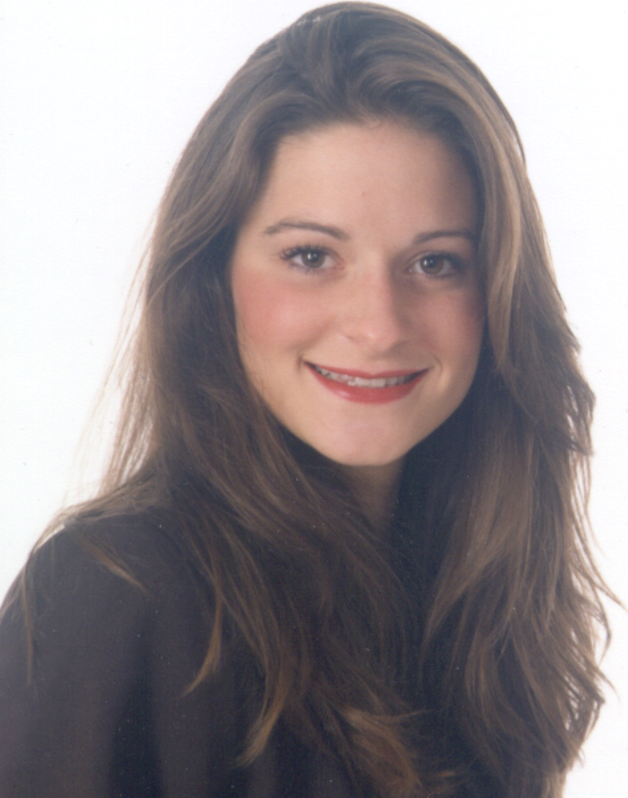
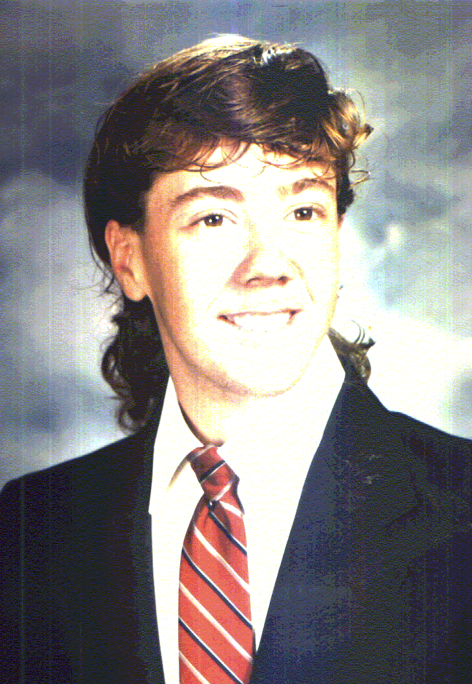
We kept in touch, and every now and again we would see each other for a few hours. We always picked up right where we left off; time didn’t ever change things. Three years ago we met again. It was Christmas time and by chance we had a week to spend getting to know one another again. Three months later our life together began again. We reestablished our friendship and slowly began to fall in love. It’s funny that neither one of us saw it happening, nor can we tell you when it did. But somehow, two became one in everything we do and feel. This is our story, True Love, chance happenings, and a strong foundation built on friendship and respect.

Today I will marry my best friend, the one that I laugh with, love, and will live with . . . Happily Ever After!

